*ASSIGNMENT – 3*

*Python Programming*

# Question-1 :

*1 . Importing Required Package Solution :*

*import pandas as pd import seaborn as sns import numpy as np*

*from matplotlib import pyplot as plt*

*%matplotlib inline*

*Question-2 :*

1. ***Loading the Dataset*** *Solution :*

*df = pd.read_csv("abalone.csv") df*

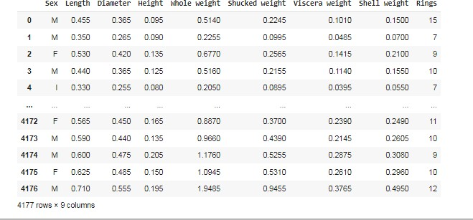*Output:*

1. ***Visualizations***

# Question-3 :

* 1. ***Univariate Analysis Solution:***

*sns.displot(df.Sex)*

*Output:*

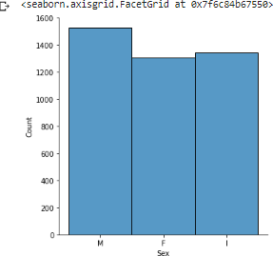

* 1. ***Bi-Variate Analysis*** *Solution:*

*df.plot.line()*

*Output:*

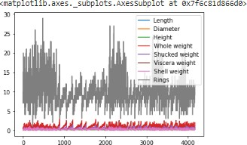

* 1. ***Multi - Variate Analysis*** *Solution:*

sns.lmplot("Diameter","Length",df,hue="Length", fit_reg=False);

*Output:*

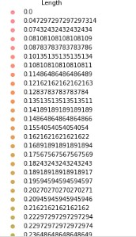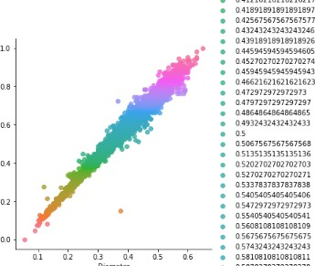

1. ***Perform descriptive statistics on the dataset.***

# Question-4 :

*Solution:*

*df.describe()*

*Output:*

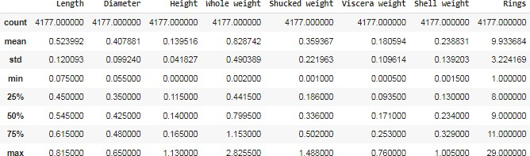

1. ***Handle the Missing values.***

# Question-5 :

*Solution:*

data = pd.read_csv("abalone.csv") pd.isnull(data["Sex"])

*Output:*

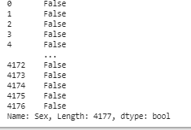

# Question-6:

1. *Find the outliers and replace the outliers. Solution:*

df["Rings"] = np.where(df["Rings"] >10, np.median,df["Rings"]) df["Rings"]

*Output:*

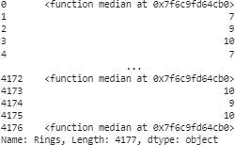

# Question-7 :

1. ***Check for Categorical columns and perform encoding.*** *Solution:*

*pd.get_dummies(df, columns=["Sex", "Length"], prefix=["Length", "Sex"]).head()*

*Output:*

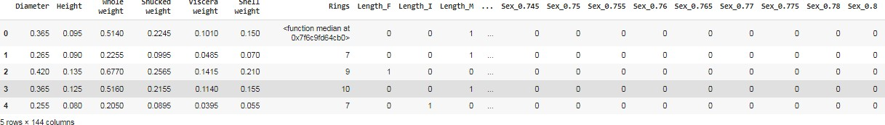

# Question-8:

1. ***Split the data into dependent and independent variables***
   1. ***Split the data into Independent variables.*** *Solution:*

*X = df.iloc[:, :-2].values print(X)*

*Output:*

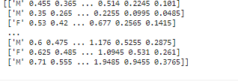

* 1. ***Split the data into Dependent variables.*** *Solution:*

*Y = df.iloc[:, -1].values print(Y)*

*Output:*



# Question-9 :

1. ***Scale the independent variables*** *Solution:*

*import pandas as pd*

*from sklearn.preprocessing import MinMaxScaler scaler = MinMaxScaler()*

*df[["Length"]] = scaler.fit_transform(df[["Length"]]) print(df)*

*Output:*

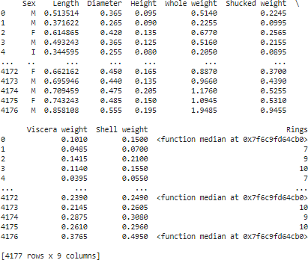

# Question-10 :

1. ***Split the data into training and testing*** *Solution:*

*from sklearn.model_selection import train_test_split train_size=0.8*

*X = df.drop(columns = ['Sex']).copy() y = df['Sex']*

*X_train, X_rem, y_train, y_rem = train_test_split(X,y, train_size=0.8) test_size = 0.5*

*X_valid, X_test, y_valid, y_test = train_test_split(X_rem,y_rem, test_size=0.5) print(X_train.shape), print(y_train.shape)*

*print(X_valid.shape), print(y_valid.shape) print(X_test.shape), print(y_test.shape)*

*Output:*

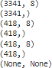

1. *Build the Model*

test_size = 0.33

seed = 7

X_train, X_test, y_train, y_test = train_test_split(X, y, test_size=test_size, random_state=seed)

1. *Train the model*

X_train

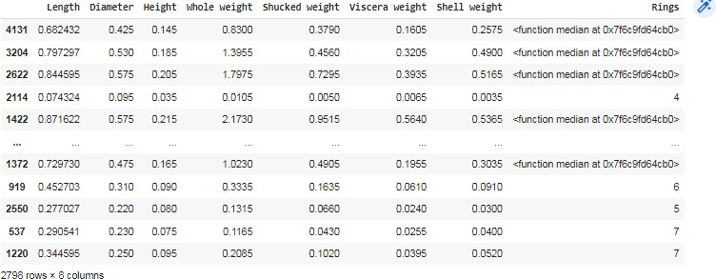*Output:*

y_train

*Output:*

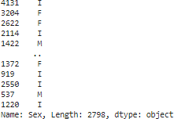

1. *Test the model: X_test*

*Output:*

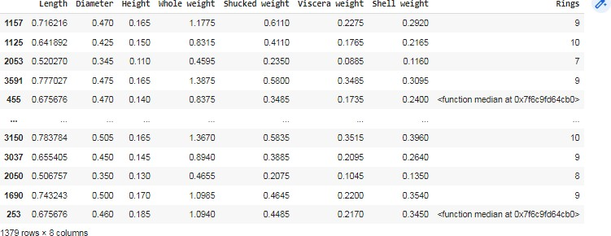

y_test

*Output:*

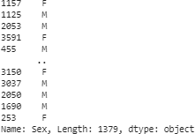

1. *Measure the performance using Metrics*

from sklearn.metrics import r2_score

from sklearn.metrics import mean_absolute_error from sklearn.metrics import mean_squared_error X_train = [5, -1, 2, 10]

y_test = [3.5, -0.9, 2, 9.9]

print ('R Squared =',r2_score(X_train, y_test))

print ('MAE =',mean_absolute_error(X_train, y_test)) print ('MSE =',mean_squared_error(X_train, y_test))

Output:

